|  |  |
| --- | --- |
| Patient Name | <Full Name> |
| Patient ID1 (CR Number) | <Patient Id 1> |
| Date of Birth | <Date of Birth> |

**= QA checks done prior to plan approval**

**= QA checks done between plan approval and Physics Check**

**= Physics check prior to treatment approval by Physicist**

**= After Physics check and Treatment Approval**

**Parameters for Eclipse Dose Calculation**

**D P**

Labels agree in ARIA: Course type, Plan ID, Reference Point Labels*.

Body is a closed structure in treated areas. No beams pass through an open area in the body contour.

***Imaging:*** CT image quality, registration, image artifacts acceptable**

Check against start date for the treatment unit in ARIA

Plan isocentre is approximately in the middle of the PTV. Y1/Y2 < 3. Shifts are in 1 cm increments.

Targets and OAR’s are contoured following correct nomenclature.

Margin to PTV as per site policy. PTV’s are 5 mm from the body surface (unless bolus is indicated).

Bolus is contoured correctly- ie. correct thickness and encompassed within the body contour

All structures are “smooth” i.e. no jagged areas or rapid change in slice-to-slice size.

Optimization “opt***” structures are appropriate.

Field ID’s are correct for gantry angle. Angles should be as per site policy.

Collimator angles have been adjusted to minimize field widths (X-direction)

H+N only: Fields adjusted to avoid the shoulder..

Algorithm, calculation grid size, and inhomogeneity correction is correct.

Calculation volume encompasses all structures needed for DVHs

Optimization parameters (dose constraints, smoothing parameters) are complete and appropriate.

Fluence fluctuation in each field is acceptable.

Dose distribution and DVH results satisfy site policy in terms of coverage, OAR limits and hotspots.

Dose and fractionation are correct.

User Origin check.

DRR’s optimized.

**After RO Plan Review and Approval (RT CHART)**

**D P**

Plan Approval done.

All signatures present/Treatment Prescription Complete.

Enter time (1.0 min) in RT Chart.

Insert graticule / field aperture contour.

Ensure OBI set-up fields are created and labeled correctly

Tolerance table correct.

Couch information entered (Long = 100.0, Imager Vrt = 50.0)

Dose limits to Primary ref point correct (considering round off issues).

Setup notes appropriate.

Dynamic Document Created, Approved.

**INDEPENDENT DOSE VERIFICATION BY PORTAL DOSIMETRY - Physicist, Dosimetrist**

**P D**

Portal Dose (PD) verification plan generated correctly.

Plan is in Course: Physics QA & labeled with the plan name and “PD QA”

Imager Vrt = 0.0

PD analysis performed, results ok and dynamic documents generated.

Header of document contains patient name, plan name, ID, and date

**Analysis Result** of all fields in table is **Passed** (Area Gamma Criteria of 3 mm/3% has a value **≥** 95%). A comment will be written in the comment section if this criteria is not met but the result is acceptable.

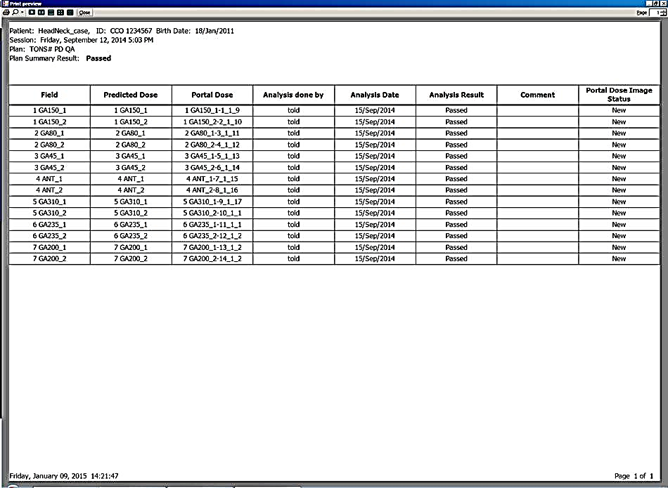

**Comment**

Matrixx verification required (Y/N):

**Matrixx is required based on EPID results or by request of the physicist**

Matrixx verification plan generated correctly. measurements performed, results ok.

Plan is in course Physics QA labeled with “Matrixx QA” and plan name

Phantom is CT phantom of Matrixx on plastic water

SSDs are 94.6 cm and MUs match original plan

Matrixx output shows patient name, ID, plan name, name of person who did the measurement

Check that no pixels are showing gamma > 1. Check histogram if applicable.

Example:

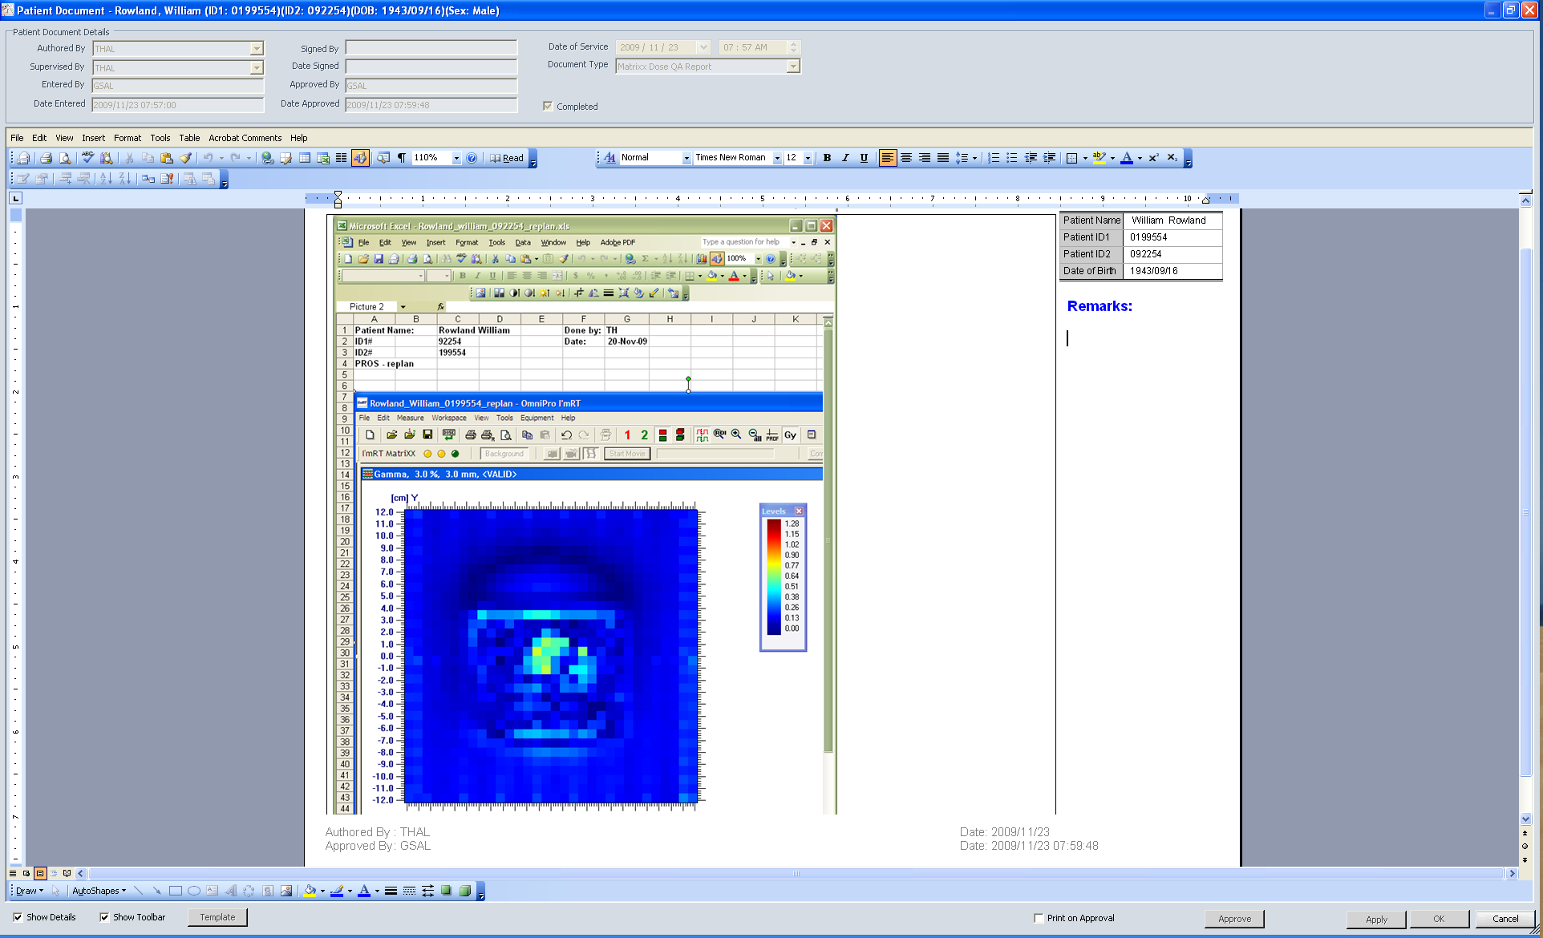

**Note: Only the physicist checks the details of this output.**

Dynamic document generated for Matrixx QA Dose Report.

|  |  |  |
| --- | --- | --- |
| Date: |  | (DD/MMM/YYYY) |

Physics check completed by .

**After Physics QA**

**D P RT**

All physicists signatures present,Treatment Approval done.

Plans used for Inhomogeneity Correction Factor check have been deleted. (ex MUREF and Temp).

Task completed.

Care path verified and appropriate workload codes assigned.

** Image artifacts are considered to be those that affect the ability to see anatomy correctly or affect the ability to achieve a desirable dose distribution. Depending on the site, these may be due to: 1) air in the rectum, 2) hip prosthesis, 3) dental fillings.

**RT Audit**

**D P RT**

**Exclude from RT Audit (Routine case; constraints met and no other concerns)**

**Note: ONLY those cases with Confidential Quality Assurance Peer Review of “No Changes Recommended will be eligible for exclusion from RT Audit**

**Comment**